# “Supported Menus” Tab

The Dealer/Seller screen needs to be extended to include a new TAB: “Supported Menus”.

New DB table has to be added which will list supported Menus. There will be NO User Interface (UI) for this table.

The table should have the following columns

* ID Field
* TPA Code
* Menu Code
* Menu Description

The Supported Menus tab will list only the “Menu Description” (alphabetical order) for the TPA the dealer belongs to.

Another DB table will be built to store the Dealer ID, Menu Code, Activation Date as well as flag indicating eRating and separate for eContracting. We should have these as Boolean.

Upon Saving the DEALER record, the menu information will be saved too. There will not be a separate save button just for this tab.

Validation – if the user selects the checkbox next to a menu, then the “Activation Date” field and eRating and eContracting checkboxes become active (blank by default). The Activation Date is required once the “Active” is checked. At least one either eRating or eContracting must be checked.

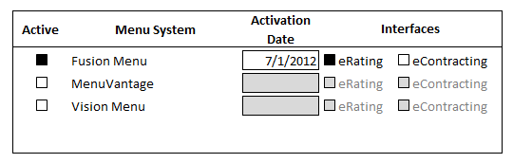

Figure 11 Menus listing